Apple IIe
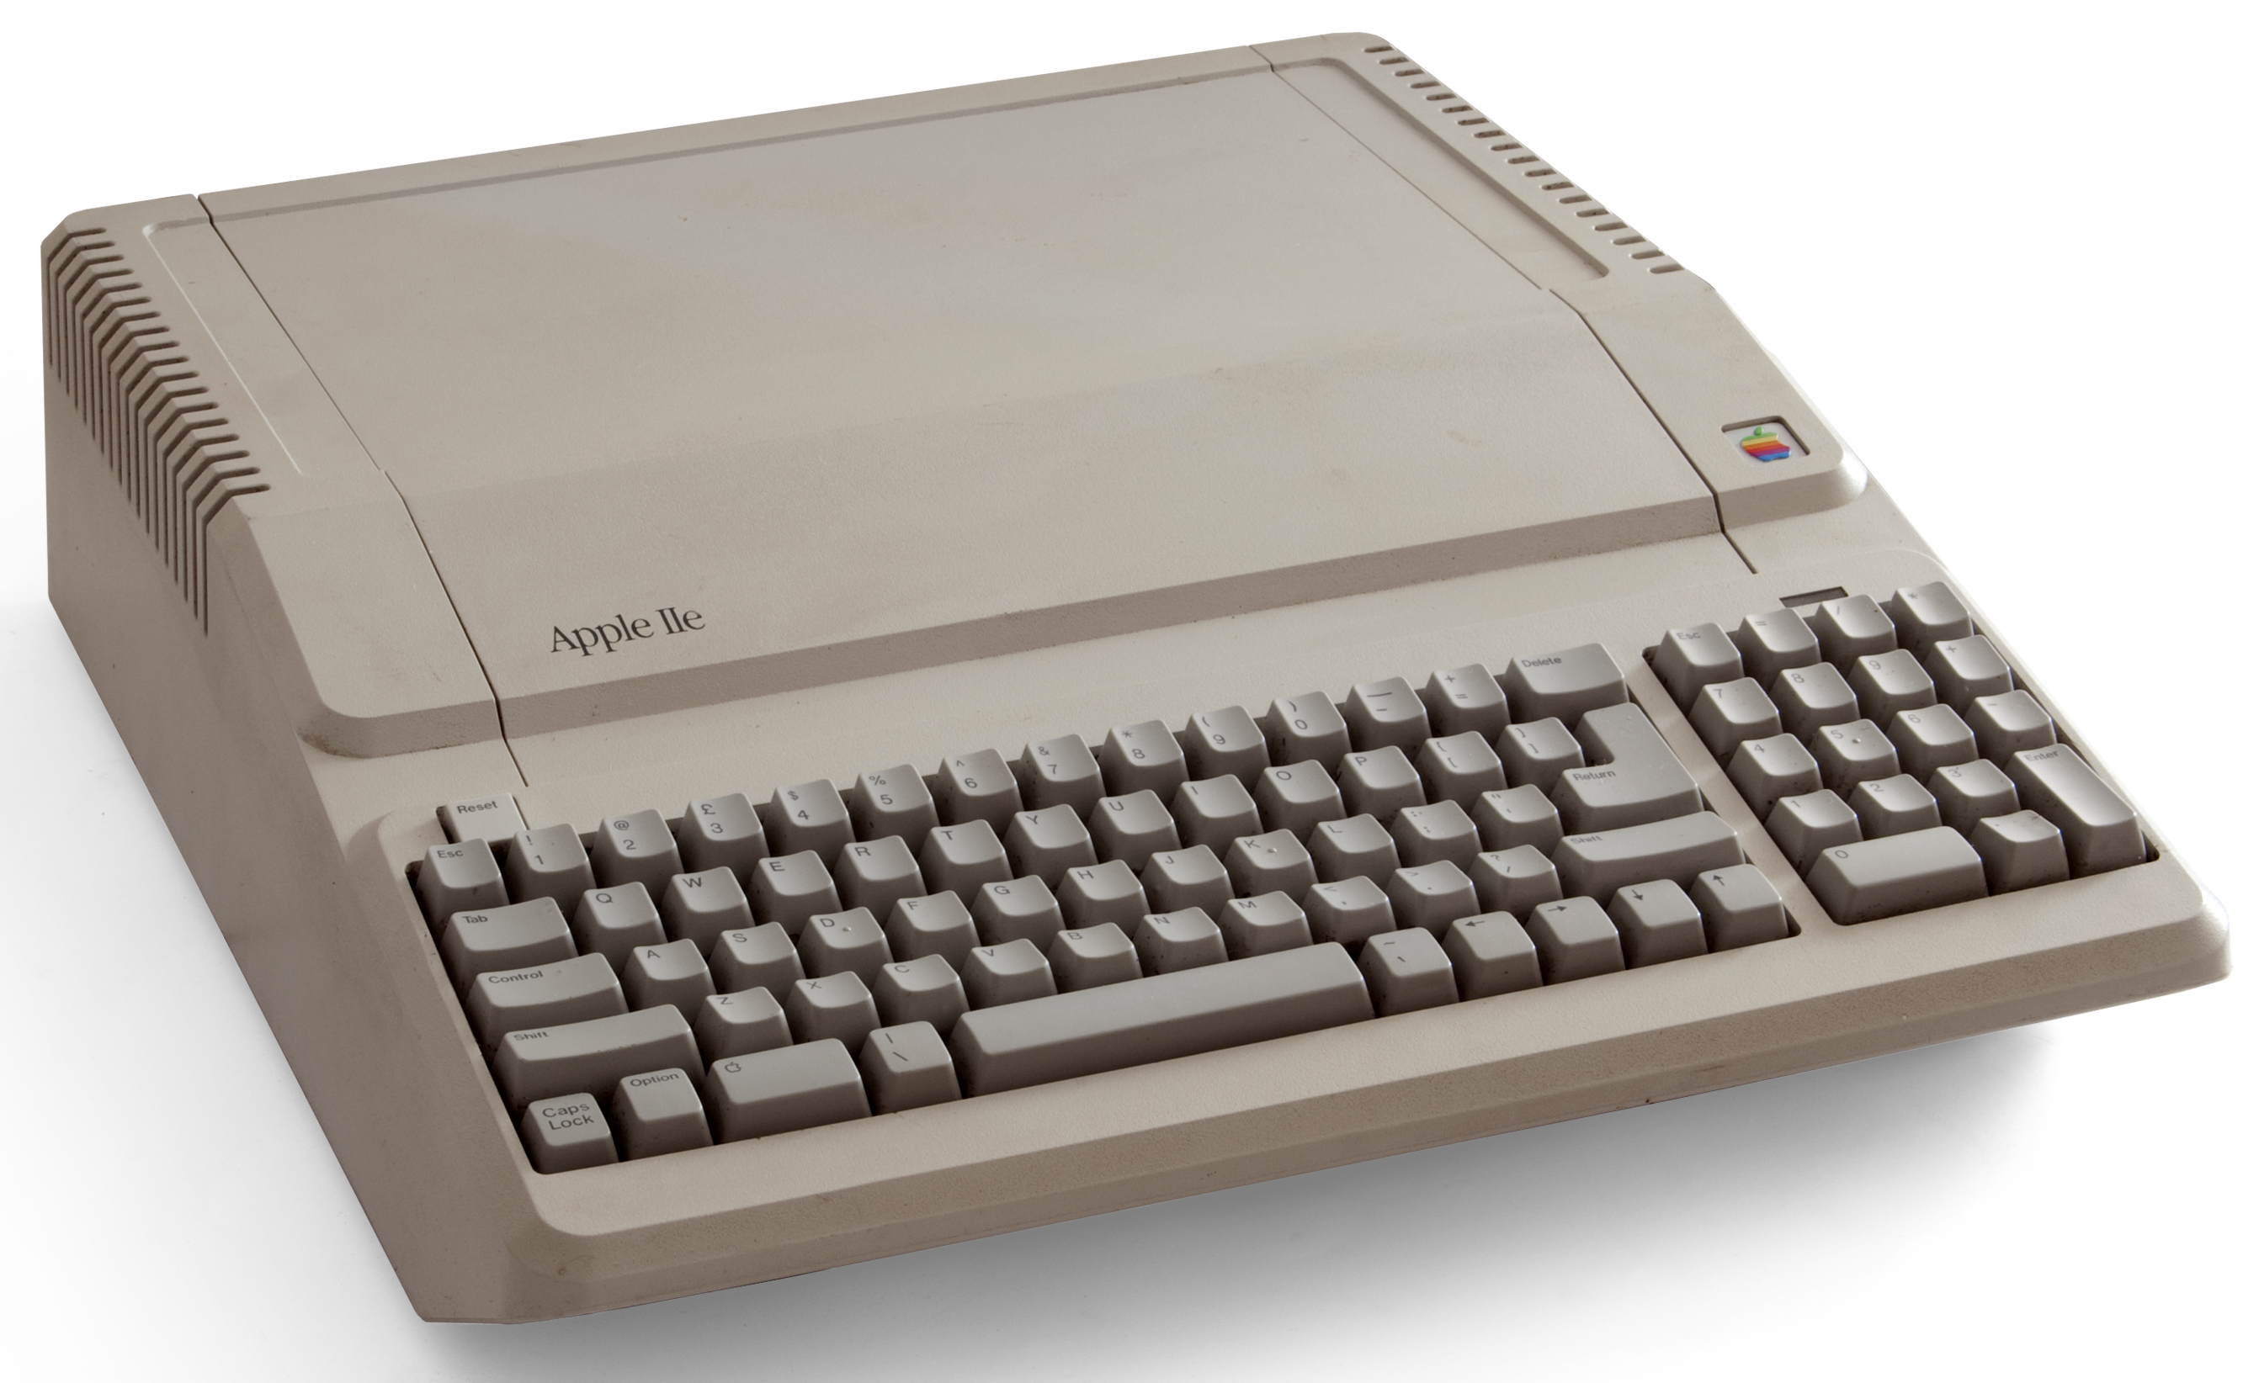

By Bilby - Own work, CC BY 3.0, https://commons.wikimedia.org/w/index.php?curid=11119627

